Curriculum Vieta

**Ankita Patil**

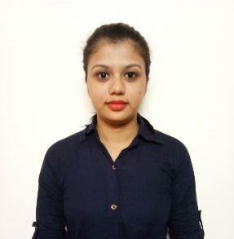**Add: - At: Girale, Near Amba Mata Temple, Post: Pargaon**

**Tal and Dist. – Palghar Saphale (E), 401102.**

**DOB: - 4th August 1995**

**Email Id: -** [ankitapatil5670@gmail.com](mailto:ankitapatil5670@gmail.com)

**Contact: - 8850456606 / 9545269433**

**Career objective**

**To work for an organization which is provide me opportunity to improve my skills. Enabling me to utilize my educational and management skills for the growth of the organization.**

**Qualification**

|  |  |  |
| --- | --- | --- |
| **Class** | **Board** | **Appeared (Year)** |
| **Pursuing Degree in Business Management** | **Pearson** | **Still Pursuing** |
| **BMS** | **Pearson** | **2016** |
| **HSC** | **Mumbai** | **2013** |
| **SSC** | **Mumbai** | **2011** |

**IT Skills**

**MS Office Excel**

**Tally**

**Research**

**Hobbies**

**Poetry Writing**

**Dancing**

**Drawing**

**Languages Known**

**English, Hindi and Marathi**

**Little bit French**

**Achievements**

**Participation certificate in Inter collage competition**

**Participating in collage sports and won 1st Prize in Cricket**

**Participate Inter collage competition and won 1st Prize in Poetry writing**

**“Nisarga Event” which is organized by me and by my classmates.**

**Member of Cultural Commete Team in Rustomjee Academy for Global Careers.**

**Skill Points**

**INTERNSHIP SKILL:**

**3month Internship in ACG Associate Capsule Pvt ltd, Dahanu (E).**

**Under Sneha Wakhre, HR Executive**

**Trainings:**

* **Recruitment and Selection**
* **Performance Management**
* **Employee Engagement**

**(Got certificate)**

**5 months Internship in ACG Associated Capsule Pvt Ltd, Kandivali (W).**

**Under Neha Deokar, HR Manager**

**Training:**

* **Training and Development**
* **Performance Management**
* **Employee Engagement**
* **Recruitment and Selection**

**Initiative Skills**

**Leadership Skills**

**Management Skills**

**Creativity Skills**

**Extra Curriculum Activities**

**Taken home Tuition of school students**

**Participating dance competition, Poetry writing and Playing Cricket.**

**Interest in Craft Work**

**Tracking**

**Drawing**

**Personal Details**

**Place of Birth: Katale**

**Marital Status: Married**

**Nationality: Indian**

**DECLERATION**

**I hereby declared that all the information made in this curriculum vitae is true complete and correct to the best of my knowledge and belief**.

**Place: - Mumbai Date: -**